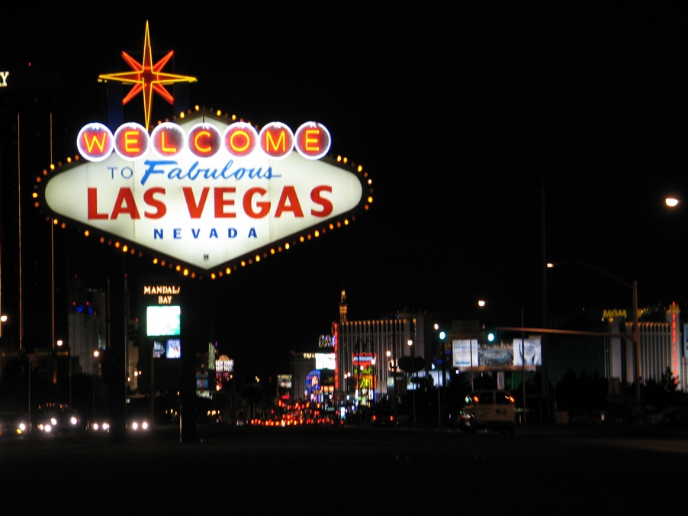
(Las Vegas Wikipedia page photo- Welcome Sign)

NHL to have first professional sports team in Las Vegas for 2017-2018 Season

by Alexander Ulatowski

When the names “Sin City” or “Entertainment Capital of the World” many people immediately think about glamorous casinos and hotels, gambling, cards and dice, poker games, the rat pack, slot machines, even Elvis Presley’s famous song Viva Las Vegas but now you will think about hockey games. On Wednesday June 22,2016 Commissioner Gary Bettman of the National Hockey League announced the league and the board of commissioners have granted an expansion team to the city of Las Vegas, and the team will enter the league in the 2017-2018 season.
The new owner of the Las Vegas franchise is Bill Foley. Bill Foley is a billionaire businessman who helped bring hockey to the city of Las Vegas by his website VegasWantsHockey.com where people were able to participate in a season ticket drive. Dan Rosen of NHL.com stated that “Las Vegas has received more than 14,000 deposits for season tickets”, “Foley said they sold roughly 400 more season tickets in the past week, and “he expects 85 percent to 90 percent of the crowds to be season-ticket holders”. Bill Foley’s team will play in the newly constructed T-Mobil Arena with a capacity of 17,368 for a NHL hockey game. Bill Foley wasn’t the only one trying to buy an expansion team, a group of investors from Quebec City, Canada called Quebecor also placed a bid to resurrect the old NHL franchise the Quebec Nordiques and the team would be playing at the Videotron Centre in Quebec. Rosen stated that the reason Quebecor’s bid fell through because of factors that included “the League's geographic imbalance within the conferences, the difficulty of bringing two new teams in at the same time, and the struggling Canadian dollar”.
With there being a new NHL team the league has brought back the Expansion Draft with will take place next summer. The Expansion Draft is where the Las Vegas Franchise gets to choose players from each team to make a roster of players. “Las Vegas must select one player from each of the existing 30 teams, including at least 14 forwards, nine defensemen and three goalies. It must select a minimum of 20 players who have existing contracts that carry through the 2017-18 season and the average annual value of the total contracts it takes on must be at least 60 percent of the 2016-17 season salary-cap limit, which is $73 million” Rosen said. The other 30 teams will be able to have the ability to protect certain players so that are not eligible for the expansion draft. Las Vegas will also have the ability to be part of the NHL Draft and will be placed into the NHL’s Draft lottery system.
By adding the 31st franchise the NHL became the first professional sports league out of the four to expand into the Las Vegas area. The remaining professional sports leagues are the National Football League (NFL), the National Basketball Association (NBA), and Major League Baseball (MLB). Las Vegas’s mayor Carolyn Goodman stated that she would “like to see three major league teams in the next decade” in the city of Las Vegas Aaron Torres of Fox Sports reported. With the NHL landing a home in the Sin City will we eventually see the NBA give an expansion team to Las Vegas or will an NFL team relocate to Vegas in the future.
In a year the Sin City will soon have its first action of professional hockey with fans gathering at the newly built T-Mobile Arena and community who will continue to support their first professional sports team. Mr. Foley is proud of being the owner of the new expansion team in Las Vegas, "We have 2.2 or 2.3 million local residents and we sold 14,000 season tickets with season-ticket deposits when we didn't have a team and we didn't have an arena. That is the kind of level of dedication that the people of Las Vegas have shown in support of NHL hockey” Foley stated.
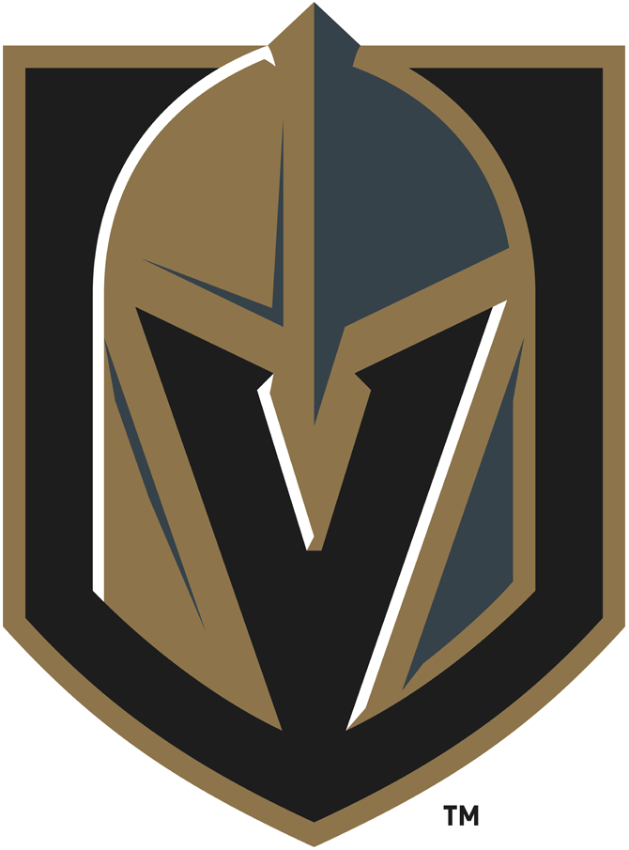 (Vegas Golden Knights Logo-Sportslogos.net)
Last November Mr. Foley announced the name of his new franchise as the Vegas Golden Knights. The Golden Knights logo was presented during a ceremony on November 22, 2016 outside of the T Mobile arena where the Golden Knights will play in the 2017-2018 season. More tourist and NHL fans will come into Las Vegas bringing in more wealth to the area and tourism industry in Vegas. Since T-Mobile Arena is on the Vegas Strip its location will play a big part in the casinos and hotels around the area from fans heading to Vegas to cheer on their favorite team.

Works Cited
Adidas Creative Services. "Vegas Golden Knights Primary Logo." Sportslogos.net. Chris Creamer, 23 Nov. 2016. Web. 31 Jan. 2017. <http://www.sportslogos.net/logos/view/611426842018/Vegas_Golden_Knights/2018/Primary_Logo>.
Almasy, Steve. "NHL Announces Plans for Las Vegas Team." CNN. Cable News Network, 22 June 2016. Web. 13 Oct. 2016.
Belson, Ken. "With N.H.L. Expansion, Las Vegas Hits the Jackpot: A Pro Team." The New York Times. The New York Times Company, 22 June 2016. Web. 13 Oct. 2016.
Rosen, Dan. "Las Vegas Awarded NHL Franchise." NHL.com. NHL, 22 June 2016. Web. 13 Oct. 2016.
Torres, Aaron. "Las Vegas Mayor: We'll Have Three 'major League' Teams in 10 Years." FOX Sports. FOX Sports, 28 June 2016. Web. 13 Oct. 2016.

